Name: Hafsa Jehanzaib
Class: BSCS
Section: 6B
Roll No: 18122035
OBJECTIVE:
Prediction of Economic growth Forecast GDP(Gross Domestic Product) trend using GDP(current US$),Inflation ,GDP deflator.
Introduction:
The dataset that is being examined offers a wide range of socio-economic indicators that are essential for comprehending and assessing the state of development in a certain area or nation. This dataset, which has columns covering demographic, economic, and developmental variables, provides a wealth of information to explore the trends, patterns,andconnections that influence a country's course throughout time.
Background:
The basis for comprehending a country's economic performance and stability is laid by economic statistics such as GDP, total reserves, gross national expenditure, and inflation rates. Particularly, GDP serves as a gauge of the state of the economy, while national spending and inflation rates provide insight into fiscal policies and methods for stimulating the economy.
Data Sources:
The dataset compiles data from a number of reliable sources, such as kaggle( the World Bank) and other statistical, economic data.
Data Preprocessing

- Handling Missing Values:
Identify and address missing values across all columns. Various techniques, such as or removal of rows/columns with significant missing data, were based on the nature and extent of missingness in each attribute. This ensured dataset's integrity while retaining valuable information.
- Binning
- Remove Duplicates
- Sorting
Modelling
Various analytical methods and algorithms were employed to extract meaningful insights from the dataset. These methods include but are not limited to:
- SVM model
- Linear regression: Utilized to understand relationships between dependent and
independent variables, such as predicting GDP based on economic indicators.
- Random forest tree
- Time series forecasting: Employed to analyze trends, seasonality, and patterns in the dataset, especially
when dealing with temporal data like population growth over years.
Evaluation Metrics:
Performance metrics utilized to evaluate the models' effectiveness. Metrics such as Mean Squared Error (MSE were considered based on the nature of the modeling task (e.g., regression random forest).

RESULTS:
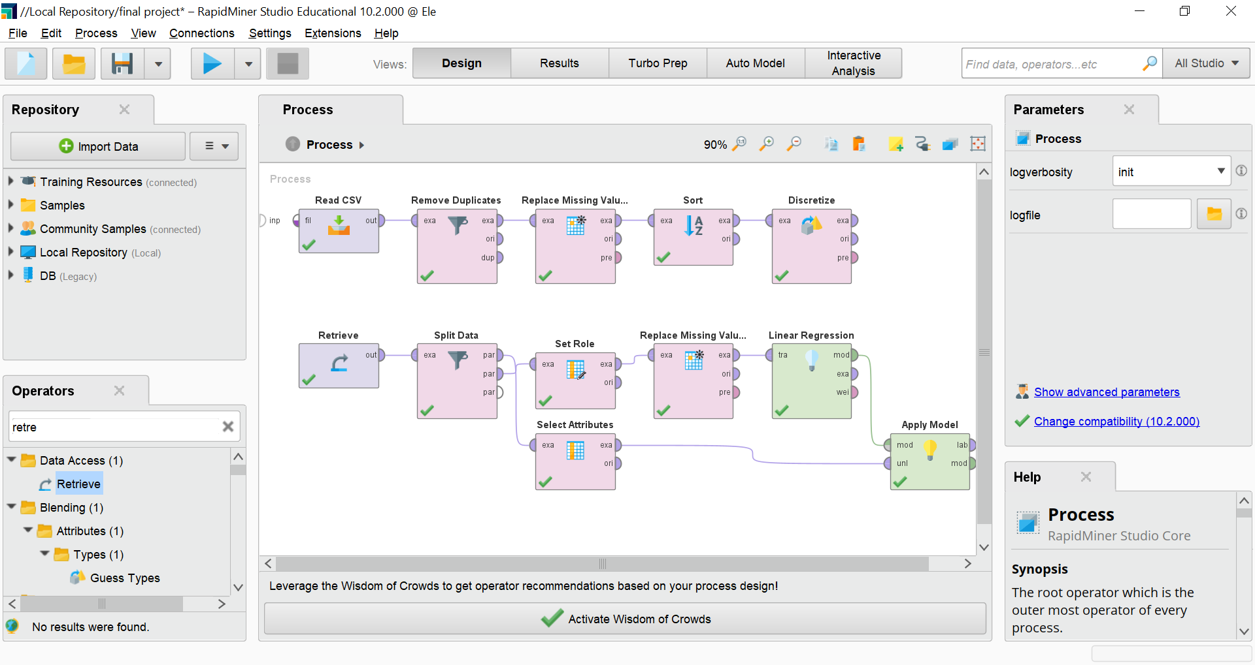
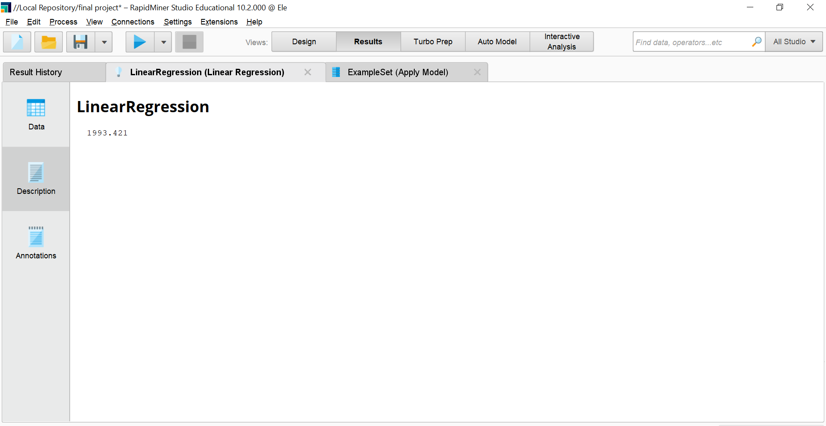
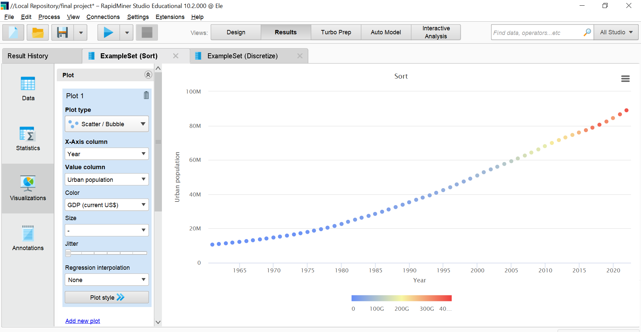

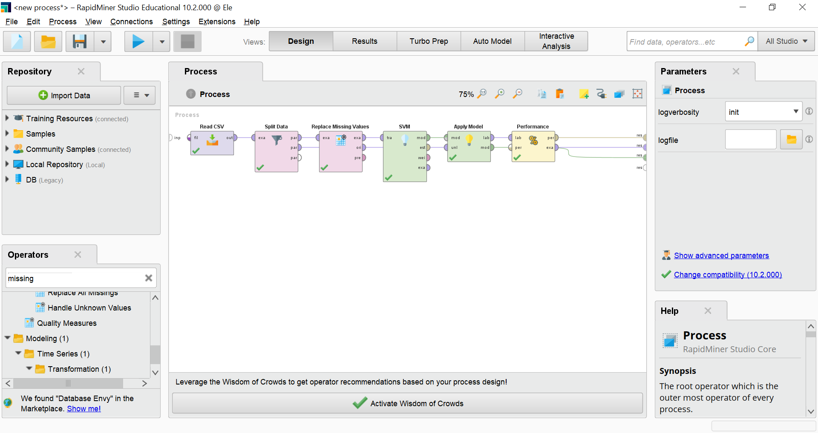
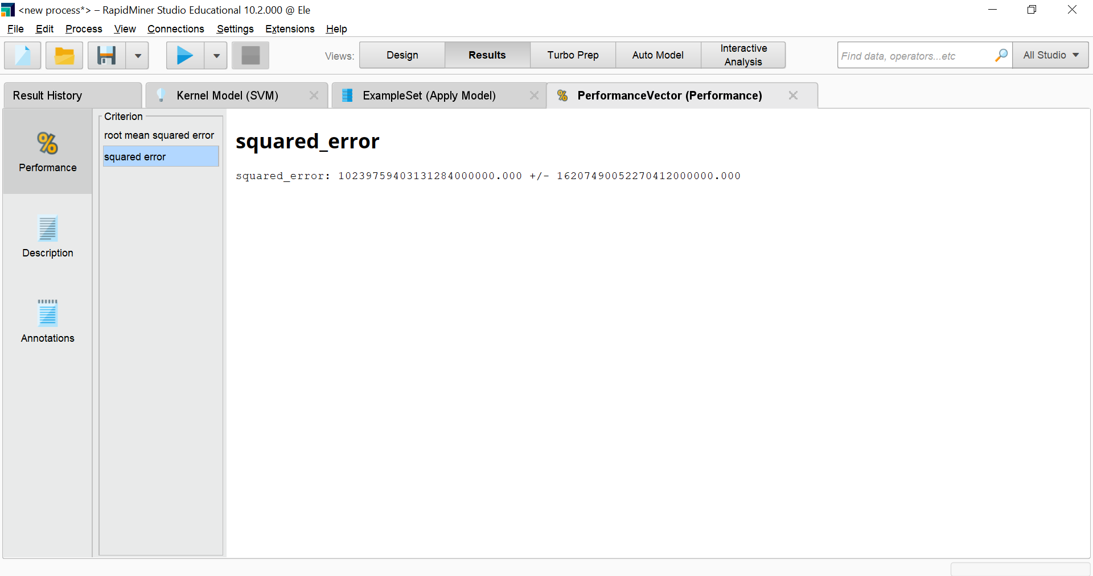
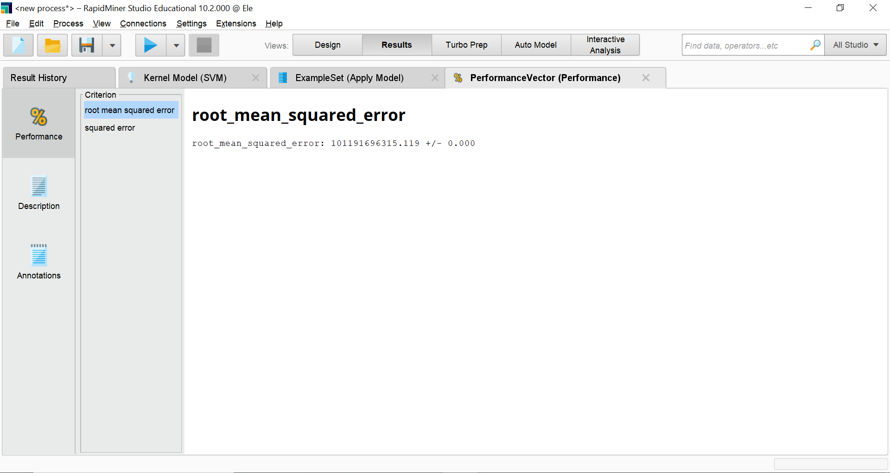
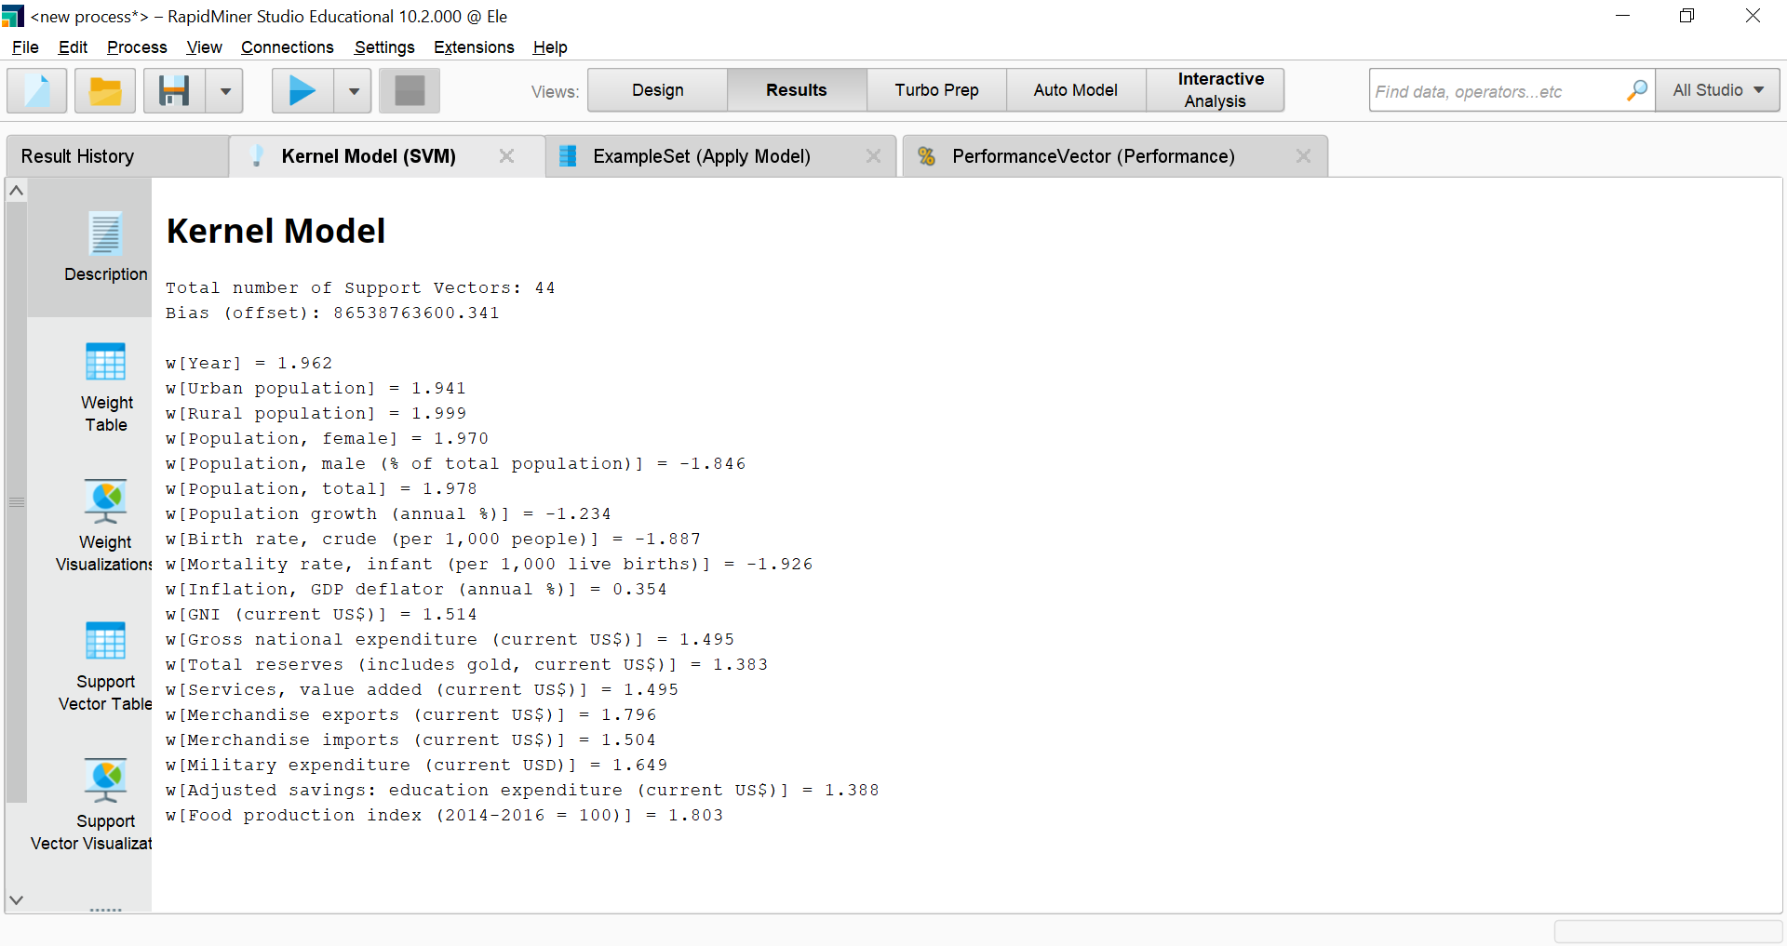
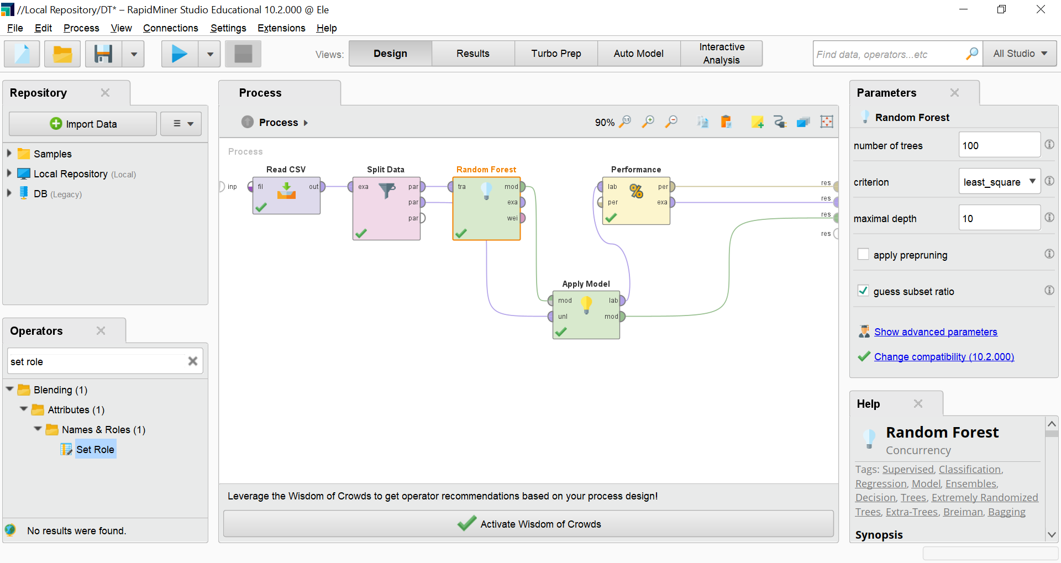

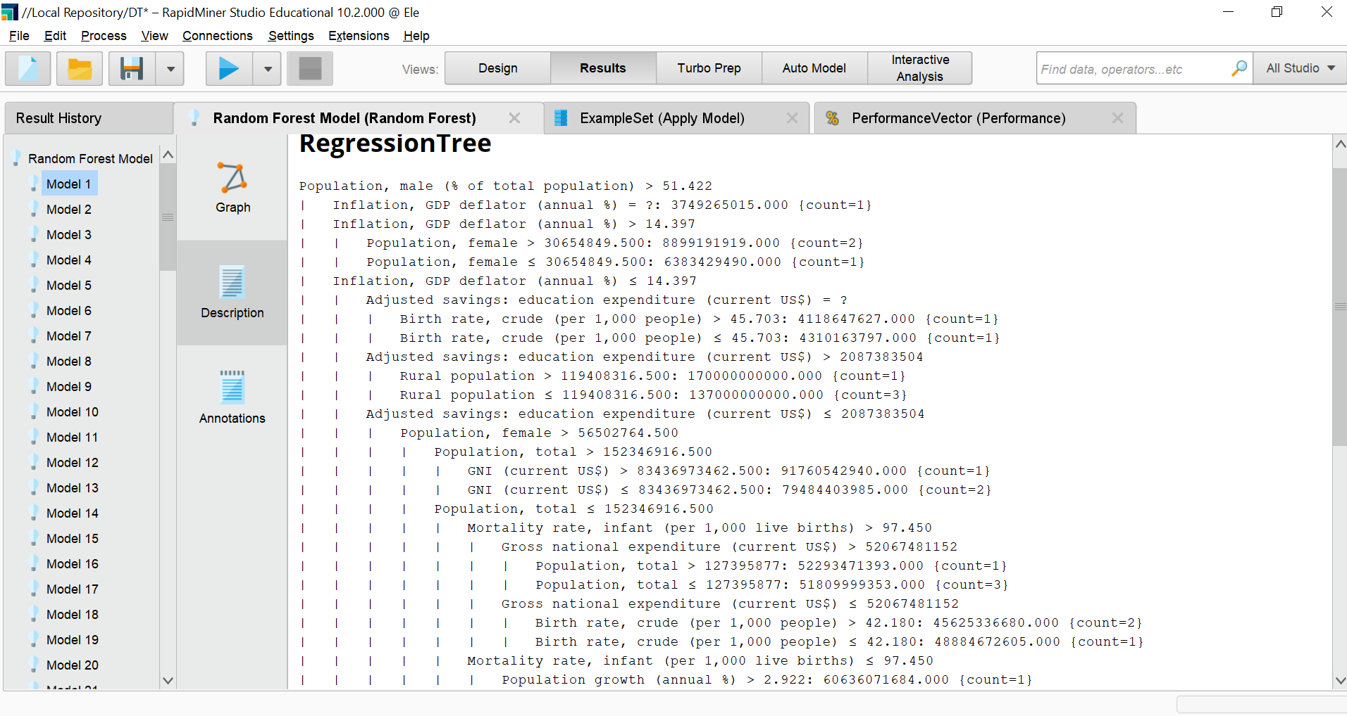
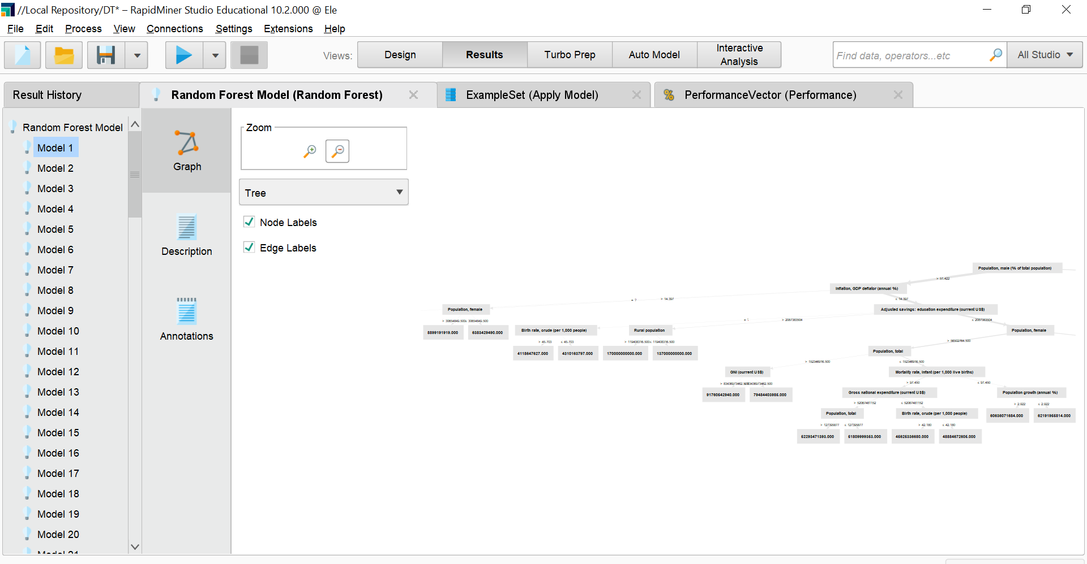
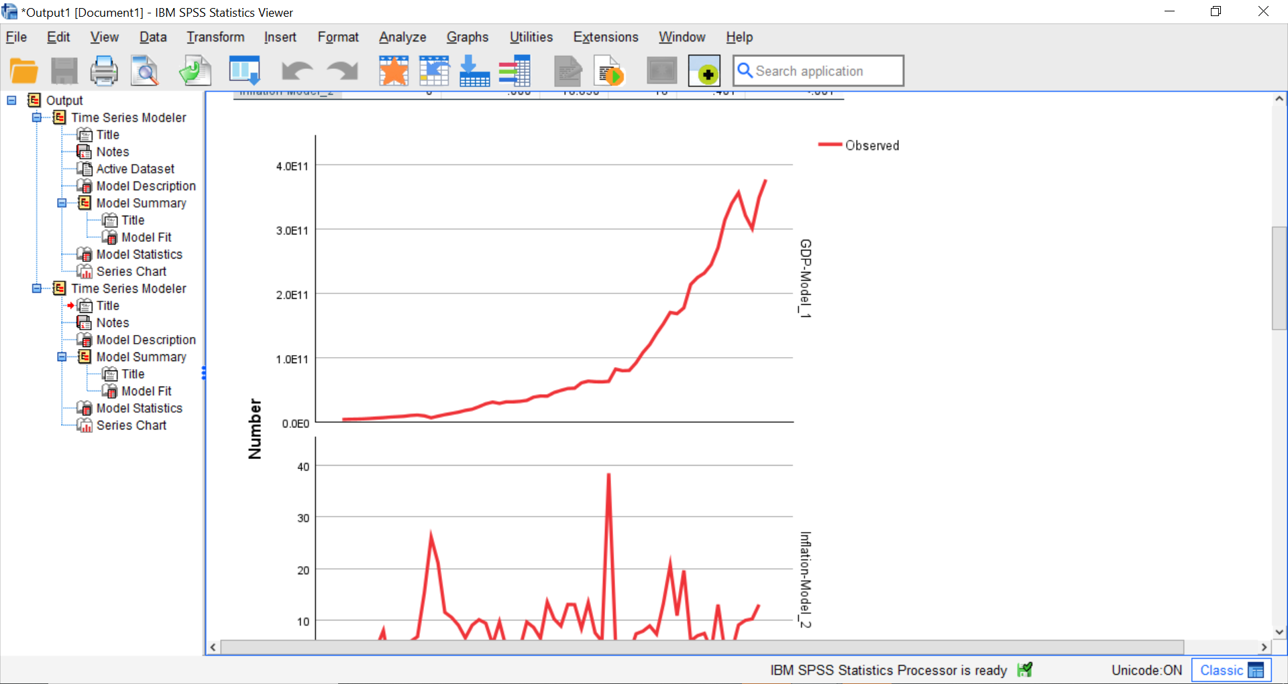
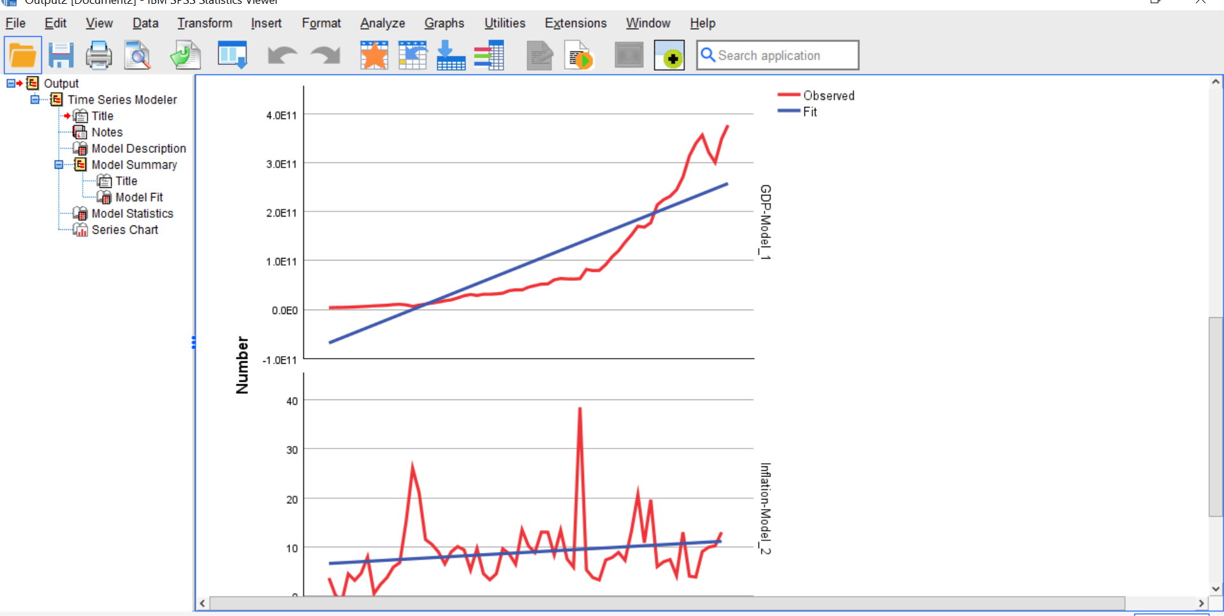jjjjjjjjjjjjj
